Project Design Phase
Solution Architecture

Date | 23 February 2026
Team ID | LTVIP2026TMIDS76018
Project Name | Rising waters: a machine learning approach to flood prediction
Maximum Marks | 4 Marks

Solution Architecture:
The solution architecture of the Flood Prediction System integrates a web-based user interface with a machine learning backend. The architecture bridges environmental data inputs and predictive flood risk output using a structured processing pipeline. The system consists of presentation layer (UI), application layer (Flask backend), preprocessing layer (StandardScaler), and machine learning layer (XGBoost model). This layered architecture ensures modularity, scalability, and efficient prediction processing.

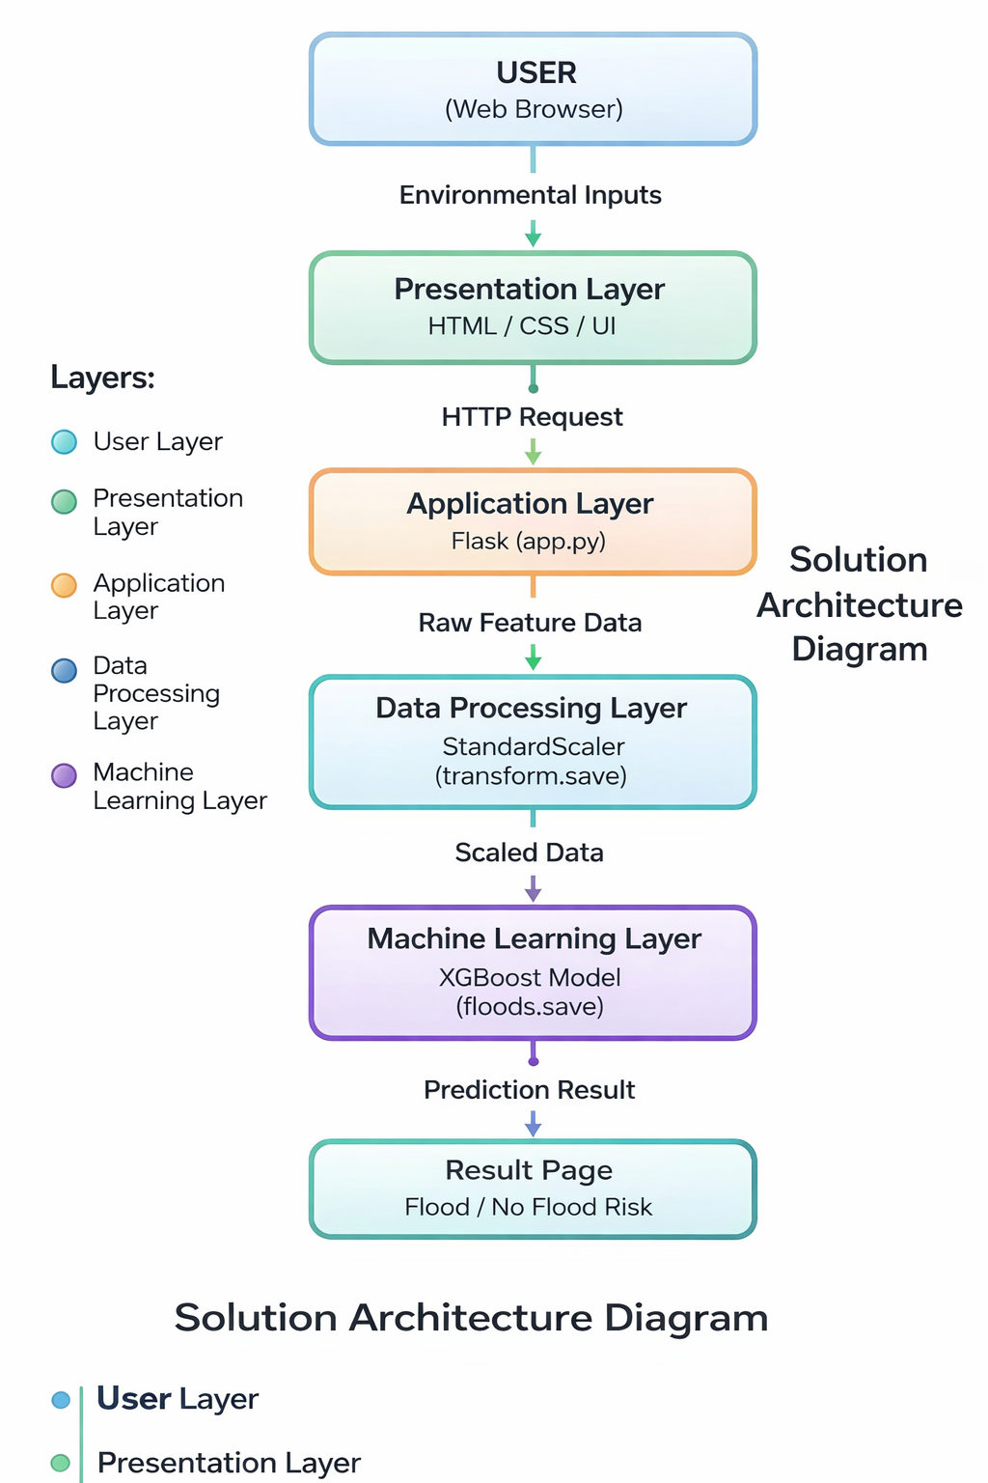

EXPLANATION OF ARCHITECTURE
- User Layer
Users enter environmental parameters through a web browser.
- Presentation Layer
HTML and CSS provide user interface for input and result display.
- Application Layer
Flask backend handles HTTP requests and processes user input.
- Data Processing Layer
StandardScaler normalizes the input features before prediction.
- Machine Learning Layer
XGBoost model predicts flood risk based on scaled data.
- Output Layer
Prediction result is displayed to user as Flood / No Flood.

